Chapter 13, Solution 13.

I₁
I₂
j2I₂
j5
+
–
j5
–
+
j2I₁
+
_
80 ∠ 0°
j2 Ω
4 Ω
4 Ω
–j Ω

–80 + (4+j5)I₁ + j2I₂ = 0 or (4+j5)I₁ + j2I₂ = 80

j2I₁ +(4+j6)I₂ = 0 or I₂ = [–j2/(7.2111∠56.31°)]I₁ = (0.27735∠–146.31°)J₁

[4+j5 + j2(–0.230769–j0.153846)]I₁ = [4+j5+0.307692–j0.461538]I₁ = 80

[4.307692+j4.538462]I₁ = 80 or I₁ = 80/(6.2573∠46.494°)
= 12.78507∠–46.494° A.

Z_{in} = 80/I₁ = 6.2573∠46.494° Ω = (4.308 + j4.538) Ω

An alternate approach would be to use the equation,

Z_{in}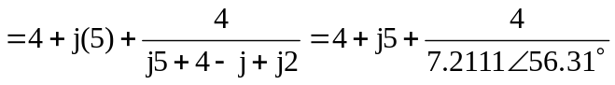
= 4+j5+0.5547∠–56.31° = 4+0.30769+j(5–0.46154)

= [4.308+j4.538] Ω.

